Project 4
Due Sunday 2/25/2018 by 11:59 PM
No delay is accepted
For each day late submission 2 points penalty is incurred.
Copy/paste your Java classes to this document and drop it into the folder Project 4 on the blackboard.
If you have any question please email me at mbadii@pace.edu

Do not delete anything from this file. Just copy/paste your java classes under the word: Answer.

Write a servlet program using the following html document to do the following:

<!-- The name of the document is Main.java -->
<html>
<head>
<meta http-equiv="Content-Type" content="text/html; charset=ISO-8859-1">
<title>Project 4 </title>
</head>
<body>
<form action="http://localhost:8080/Project/Main" method = "get">
Enter Your Name: <input type="text" name="yourName"><br>
<input type="submit" value="Click to submit">
</form>
</body>
</html>

Note: You must not change this html document.
Note: The name of your java project in eclipse must be: Project with uppercase: P.

Note: The name of the Servlet class must be: Main.

1. The user enters a new name:

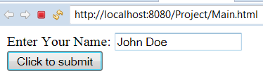

Then clicks on the button:

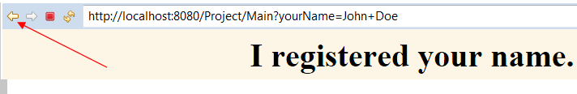

After the user clicks on the yellow arrow several times and enters several names one by one:
For example:

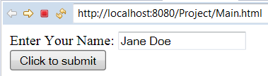

....

Now the user enters one of those names and clicks on the button:

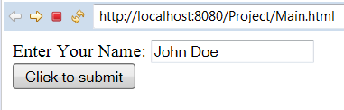

The following page should show up:

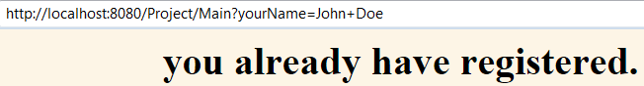

Hints:
To store the names I used Java Vectors (lecture 3, example 8, page 23.
For making the dynamic html document at execution time look at lecture 4, example 8, page 30 and example 7, page 25.

Only copy Main.java under the word: Answer. Do not copy any html document.
Answer

The Servlet class is:

import java.io.IOException;
import java.io.PrintWriter;
import javax.servlet.ServletException;
import javax.servlet.annotation.WebServlet;
import javax.servlet.http.HttpServlet;
import javax.servlet.http.HttpServletRequest;
import javax.servlet.http.HttpServletResponse;
import java.util.Vector;

/**
* Servlet implementation class Main
*/
@WebServlet("/Main")
public class Main extends HttpServlet {
private static final long serialVersionUID = 1L;
private Vector<String> clientList;

/**
* @see HttpServlet#HttpServlet()
*/
public Main() {
super();
// TODO Auto-generated constructor stub
clientList = new Vector<String>();
}

/**
* @see HttpServlet#doGet(HttpServletRequest request, HttpServletResponse response)
*/
protected void doGet(HttpServletRequest request, HttpServletResponse response) throws ServletException, IOException {
// TODO Auto-generated method stub
String html = "<html><title>Project 4</title><body>\n<h1 style='width: 100%; text-align:center;'>";

String name = request.getParameter("yourName");
if(clientList.contains(name)) {
html += name + " has already been registered.";
}
else {
clientList.addElement(name);
html += name + " has been registed.";
}

html += "</body></html>";

//response.getWriter().append("Served at: ").append(request.getContextPath());
PrintWriter out = response.getWriter();
out.println(html);
out.close();

}

/**
* @see HttpServlet#doPost(HttpServletRequest request, HttpServletResponse response)
*/
protected void doPost(HttpServletRequest request, HttpServletResponse response) throws ServletException, IOException {
// TODO Auto-generated method stub
doGet(request, response);
}

}

